**Analyzing the Impact of Car Features on Price and Profitability**

**Final Project-3**

**Project Overview:**

The automotive industry has been rapidly evolving over the past few decades, with a growing focus on fuel efficiency, environmental sustainability, and technological innovation. With increasing competition among manufacturers and a changing consumer landscape, it has become more important than ever to understand the factors that drive consumer demand for cars . For the given dataset, as a Data Analyst, the client has asked How can a car manufacturer optimize pricing and product development decisions to maximize profitability while meeting consumer demand?

This problem could be approached by analyzing the relationship between a car's features, market category, and pricing, and identifying which features and categories are most popular among consumers and most profitable for the manufacturer.

**Business Objective:**

To find car features that influence its pricing so that a manufacturer can optimize pricing and take product development decisions to maximize profitability while meeting consumer demand

**Dataset:**

The dataset contains information on over 11,000 car models and their specifications, including details on the car's make, model, year, fuel type, engine power, transmission, wheels, number of doors, market category, size, style, estimated miles per gallon, popularity, and manufacturer's suggested retail price (MSRP).

Raw dataset link:

<https://drive.google.com/file/d/10OJxyi3TexbRHb7JrS_YaWs2oc-WyvuB/view?usp=sharing>

**Approach:**

By using data analysis techniques such as regression analysis and market segmentation, the manufacturer could develop a pricing strategy that balances consumer demand with profitability, and identify which product features to focus on in future product development efforts. This could help the manufacturer improve its competitiveness in the market and increase its profitability over time.

**Tech-Stack Used:**

Microsoft Excel 2022

**Insight Required:**

1.How does the popularity of a car model vary across different market categories

**2.** What is the relationship between a car's engine power and its price?

**3.** Which car features are most important in determining a car's price?

Regression Analysis



SUMMARY OUTPUT

Regression Statistics

Multiple R :0.67693217

R Square :0.458237163

Adjusted R Square :0.458009627

Standard Error :44257.14587

Observations :11911

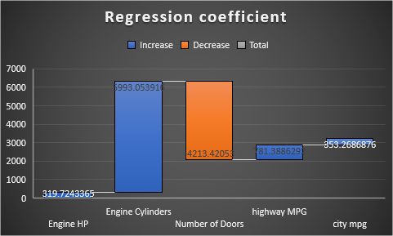

**4.** How does the average price of a car vary across different manufacturers?

|  |  |  |
| --- | --- | --- |
| MSRP | Brand | Average |
| Highest | Bugatti | $17,57,223.7 |
| Lowest | Plymouth | $3,122.9 |

**5.** What is the relationship between fuel efficiency and the number of cylinders in a car's engine?

|  |  |
| --- | --- |
| Correlation coefficient | -0.60094 |

**Interactive Dashboard:**

**Task 1:** How does the distribution of car prices vary by brand and body style?

**Task 2:** Which car brands have the highest and lowest average MSRPs, and how does this vary by body style?

|  |  |  |
| --- | --- | --- |
| MSRP | Average | Brand |
| Highest | 1757223.7 | Bugatti |
| Lowest | 2000.0 | Suzuki |

**Task 3:** How do the different feature such as transmission type affect the MSRP, and how does this vary by body style?

**Task 4:** How does the fuel efficiency of cars vary across different body styles and model years?

**Task 5:** How does the car's horsepower, MPG, and price vary across different Brands?

Link to dashboard:

<https://docs.google.com/spreadsheets/d/1LL8vqU_uxT8sEZrY3qCLjwNums3BQwrs/edit?usp=sharing&ouid=100819582638973735490&rtpof=true&sd=true>

**Business Insights Gained:**

* Bugatti has the highest price where Plymouth has lowest average price
* The number of cylinders in a car has a negative impact on the fuel efficiency
* Engine HP is a determining factor on the car’s MSRP , The regression analysis gives highest coefficient and zero p value and low standard error
* Luxuary cars have the highest popularity
* There is an overall increase in fuel efficiency over the years
* Bugatti has the highest horsepower , highest MSRP and lowest fuel efficiency